Violence against women data analysis
using PCA, Logistic Regression and Decision Trees

Gherasim Delia-Cătălina
Applied Computational Intelligence
Group 246-1

Abstract

Intimate partner violence (IPV) remains a prevalent global issue, shaped by complex socio-demographic and attitudinal factors. In order to explore patterns and predictors of IPV justification we applied 3 data analysis methods: Principal Component Analysis (PCA), logistic regression and decision trees on a dataset from the Demographic and Health Surveys. PCA was used to reduce dimensionality and determine the primary demographic structures influencing IPV. Rural residence, employment status and marital status dominated the variance. Logistic regression models examined binary outcomes for survey questions, highlighting the influence of demographic predictors. Decision tree analyses with SMOTENC oversampling identified gender and prior survey responses as the strongest determinants. The results exemplify the role of demographic context and attitude correlations in IPV justification, providing insights for targeted interventions.

Contents
Abstract 1
I. Introduction 3
II. Related work 4
III. Theoretical aspects 5
- Principal Component Analysis 5
- Logistic Regression 6
- Decision Trees 6
IV. Dataset 7
V. Data preprocessing 8
VI. Data analysis 10
- Principal Component Analysis 10
- Logistic regression 14
- Decision Trees 19
VII. Conclusion 22
Bibliography 22

Introduction

Relevance of the chosen topic
Intimate partner violence (IPV) remains a critical global health and human rights challenge. Understanding the justification of violence is important for developing effective preventive measures. The acceptance of violence allows harmful norms to persist, serving as a powerful barrier to policy implementation and change.

Objectives
This study presents a data analysis of factors influencing intimate partner violence by using Principal Component Analysis (PCA), Logistic Regression (LR) and Decision Trees (DT) on data from the Demographic and Health Surveys (DHS). The data captures socio-economic patterns related to IPV justification across 70 countries in Africa, Asia and South America. The survey focuses on respondent attitudes toward six distinct scenarios of violence justification. The justification of IPV is a complex, multi-layered social phenomenon, where the structural demographic context influences likelihood, but the immediate predictive drivers are highly specific and often non-linear. The 3 models revealed different structures of influence.

Contributions
PCA identified the features that define the demographic characteristics underlying the data’s variation as rural residence, youth and marital status. This technique was performed without pre-specifying the number of components, allowing the full structure of variance to be inspected. Approximately 9 components were sufficient to account for 90% of the total variation, demonstrating that the original variables are highly correlated. One hot encoding was preferred for analysis of component loadings, as it allowed for inspection of individual categorical feature contributions. Logistic regression was applied separately to each of the six IPV justification items to model the log-odds of a positive survey response based on demographic predictors. The models using mean-based thresholds to define binary outcomes and preserve natural response distribution had llow precision and F1-scores due to the heavily skewed data. Alternative strategies improved minority class representation, but introduces artificial thresholds. After eliminating the Country feature the models improved significantly. This revealed that the strongest coefficients for IPV justification were rural residence, specific employment status and marital status. Decision trees, which used the Synthetic Minority Oversampling Technique for Nominal and Categorical data (SMOTENC) to correct class imbalance, found that the gender male and the interdependence of justification attributes were the immediate predictors for the classification of IPV. The use of SMOTENC was important in overcoming structural demographic bias to reveal the predictive features.

The following section describes related work in which the 3 methods were used for IPV data analysis. Chapter three briefly describes the theoretical aspects. Chapter four presents an overview of the useddataset, while Chapter five presents the preprocessing pipeline. Finally, the data analysis is described for each method in chapter six.

Acknowledgement:
This work is the result of my own activity, and I confirm I have neither given, nor received unauthorized assistance for this work. I declare that I used generative AI or automated tools in the creation of content or drafting of this document. I used Gemini to summarize my initial notes and correct the logical flow as well as to proofread my final draft and correct the grammar. All the text impacted by generative AI has been explicitly marked as such in this document.

Related work

Principal Component Analysis

The study (Hacıaliefendioğlu A, 2020) looks at how different forms of intimate partner violence co-occur using data from the National Intimate Partner and Sexual Violence Survey (NISVS). PCA was used to reduce the 39 survey items into a 2-dimensional space, revealing that violence varies systematically by both intensity and type and showing a clear separation between survivor subgroups. This analysis also helped identify a fourth category: micro-aggression. The study highlighted subgroups and patterns of IPV that can help in survivor assessment and interventions.

Logistic regression

In the study (Anasel, 2024), logistic regression was applied to identify factors influencing Intimate Partner Violence (IPV) in Tanzania, modeling the likelihood of experiencing IPV(yes/no). The model estimates the log-odds of the event as a function of predictors, with coefficients interpreted as odds ratios: positive values increase the probability of IPV, negative values decrease it. Analysis started with univariable models for each predictor, followed by multivariable logistic regression using only significant predictors, to identify the key factors associated with IPV.

Decision trees

The study (Coll CV, 2021) examines IPV across 48 low and middle income countries using a decision tree approach to identify women at highest risk. Decision trees were used because they capture complex intersections between demographic and behavioral indicators without requiring prior assumptions. Using CART, the analysis identified the groups of women exposed to IPV, helping highlight context-specific risk profiles that can guide prevention efforts. The model showed that childhood exposure to IPV, low empowerment and partner alcohol use were the strongest markers of increased risk.

Theoretical aspects

Principal Component Analysis

Principal Component Analysis (PCA) is a statistical technique used to reduce the number of variables in a dataset while retaining as much of the important information as possible. This is performed by transforming the original variables into a new set called principal components, which are linear components of the original features. By keeping only the most important features, PCA shows a lower-dimensional approximation of the original dataset that reflects the major patterns. PCA is used when the variables are correlated, because the method identifies and combines shared patterns into fewer components. (Greenacre, 2022)

PCA finds new principal components that capture the largest patterns in the data, are uncorrelated and provide the best lower-dimensional representation. The first principal component (PC1) extracts the strongest pattern in the data by capturing the largest possible variance in the dataset. The higher the variance, the more information or “inertia”. The importance of a component is reflected by its inertia, or the proportion of total inertia it explains. The second principal component (PC2) must be orthogonal to PC1 and must capture the next largest possible variance. This ensures that PC1 and PC2 represent independent patterns. All other components must be orthogonal to all previous ones.

Let our dataset be written as a $I×J$ matrix X, where $x_{i,j}$ denotes the element on row i and column j. The matrix has rank $L ≤min⁡(I,J)$. Before PCA, X is usually centered or standardized. PCA is computed using the singular value decomposition (SVD) of X:

$X=PΣQ^{T}$ where P = $I×J$ matrix of left singular vectors
Q = $J×L$ matrix of right singular vectors
$Σ$ = diagonal matrix of singular values

Each column of P represents a principal component direction in the space of observations. Multiplied by the singular values, they produce the coordinates of each observation in the PCA space, known as the factor scores. The columns of Q describe the loadings, meaning how each original variable contributes to each principal component. A large value in Q means that the variable strongly influences the PCA direction. The singular values determine the amount of variance explained by each principal component, and their squares correspond to the eigenvalues of $X^{T}X$. The magnitude of each singular value provides a direct measure of the importance of the associated component in capturing the structure of the data. An observation’s contribution to a component is measured by the ratio of its squared factor score to the component’s eigenvalue, while the squared cosine indicates the component’s importance for that observation. Large loadings reveal which variables are well represented. Together, the factor scores and loadings provide a lower-dimensional representation of the dataset that preserves the maximum possible variation from the original variables. (Abdi H, 2010)(Paragraph written with the help of generative Ai)

This lower-dimensional representation is usefull for visualizing and interpreting complex datasets more easily, highlighting the observations and variables that contribute most to the underlying patterns. By examining factor scores, loading and the proportion of variance, we can identify which variables influence major trends in the data and which observations are the most representative.

Logistic Regression

Linear regression, which models a continuous response variable, is not suitable for cases where the response variable is binary. In such cases logistic regression is used. Logistic regression models the logit of the probability that the outcome equals one:

` $logit\left(p\right)=\ln\left(\frac{p}{1-p}\right)= α+β_{1}X_{1}+…+β_{k}X_{k}$

The logit is the natural logarithm of the odds of the event happening. The coefficients in logistic regression are interpreted using the odds ratios, which indicate how the odds of the event change with a one-unit increase in a predictor (an explanatory variable that may influence the outcome). (Best, 2015) The intercept represents the expected log-odds of the event when all predictors are 0.
For a single predictor X, the model can be written as:

$$\ln\left[odds\left(Y=1\right)\right]= β_{0}+β_{1}X$$

Y=1 indicates that the event occurs, $β_{0}$ is the intercept and $β_{1}$ represents the change in the log-odds of the event for a one-unit change in X. Logistic regression assumes a linear relationship between the predictor and the log-odds, otherwise continuous predictors can be transformed into categories or preprocessed. Model interpretation focuses on how predictors increase or decrease the odds of the event. Values greater than 1 for coefficients indicate increased odds of the event. (LaValley, 2008) Confidence intervals are used to determine statistical significance.

Decision Trees

A decision tree consists of nodes and branches, with the main steps of building a model being splitting, stopping and pruning. Nodes include the root node as the starting point, internal nodes that represent decisions and leaf nodes as the final outcomes. Branches connect nodes. Each path from root to leaf corresponds to a classification rule, which can be expressed as an if-then rule. Decision trees can also be visualized as segmented spaces, where each segment corresponds to a leaf node. Each record is assigned to a single segment, and the goal is to optimally subdivide records to accurately predict the outcome. (Song, 2015)

Splitting divides nodes into subsets based on predictors most strongly related to the target. Decision tree algorithms use measures such as information gain, gain ration or the Gini index to evaluate how well each split separates the classes. Both continuous and categorical predictors can be used, and variables may appear multiple times at different levels. In an attribute space, each split corresponds to inserting a decision boundary like a hyperplane perpendicular to a single attribute.

Stopping rules prevent overfitting by limiting tree complexity. Pruning reduces tree size by removing branches that add little predictive power and is essential to improve generalization. This is used because real data often contains errors or mislabeled cases that can make a tree grow overly complex. Methods include pre-pruning (preventing non-significant splits) and post-pruning (trimming after full tree growth). (Song, 2015)

Dataset

The “Violence against women & girls” dataset was obtained from Kaggle and can be found at: https://www.kaggle.com/datasets/whenamancodes/violence-against-women-girls .

The Demographic and Health Surveys Program, funded by the United States Agency for International Development (USAID), performed a survey on 70 African, Asian and South American countries. The survey focuses on justifications given for committing acts of violence against women and the sociodemographic groups the respondents belong to. The answers were provided by both men and women.

The data contains 12600 entries and is structured by record Id, country, gender, demographics, survey year and the percentage of people in the survey group who agree with the following statements:
- A husband is justified in hitting or beating his wife if she burns the food
- A husband is justified in hitting or beating his wife if she argues with him
- A husband is justified in hitting or beating his wife if she goes out without telling him
- A husband is justified in hitting or beating his wife if she neglects the children
- A husband is justified in hitting or beating his wife if she refuses to have sex with him
- A husband is justified in hitting or beating his wife for at least one specific reason

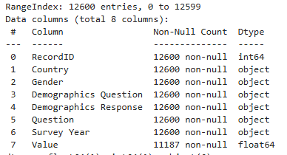
Figure 1 Initial dataset structure

The “Demographics question” column includes marital status, employment, age, residence and education.

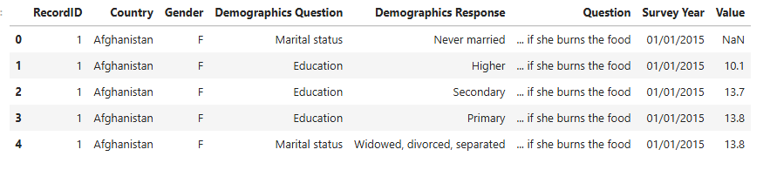
Figure 2 Initial dataset example

Data preprocessing

For the preprocessing pipeline we performed the steps:

- Date handling
The Survey Year column was converted into a datetime format to standardize the date information. The calendar year was extracted, and the original column was removed.
- Reshaping demographic information
Demographic information was stored in question-response pairs. This was reshaped into a wide format using a pivot table so that each demographic question formed its own column. This allows each demographic variable to be a separate feature.
- Merging question responses
The responses to the survey questions were also pivoted to create one column per survey question. These were merged with demographic features to obtain a unified dataset containing predictors(demographics) and outcomes (question responses).
- Encoding categorical variables
The features: country, age, education, employment, marital status and residence were categorical.
- Handling missing data
Missing values in the dataset were replaced with zeros, to avoid errors during scaling.
- Removing non-numeric identifiers
The columns RecordId and Year were removed to avoid introducing biased correlations.
- Scaling

Principal Component Analysis:
The encoding of categorical variables was performed using label encoding and one-hot encoding.
All numeric features were standardized using StandardScaler. This made the data suitable for PCA by placing variables on a comparable scale and preserving the structure. The final dataset for PCA had 840 entries and the structure in Figure 3a for label encoding and Figure 3b for one hot encoding.

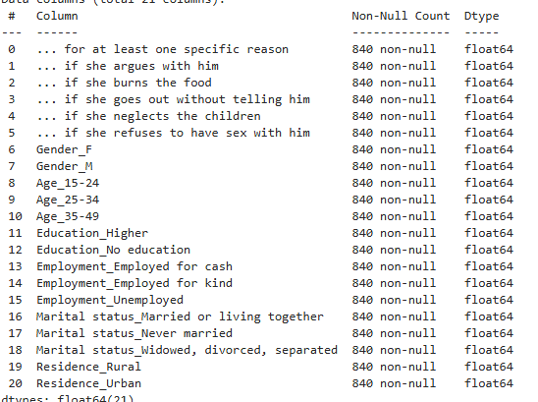

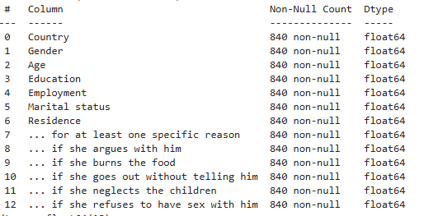
Figure 3a Dataset structure after preprocessing with label encoding
Figure 3b Dataset structure after preprocessing with one hot encoding
Logistic regression:
For the logistic regression analysis, we used one-hot encoding for all categorical features and numeric predictor variables were standardized using StandardScaler. This ensures that features contribute equally during model training. The preprocessing steps were implemented as a scikit-learn ColumnTransformer for consistency between the training and test data. The final dataset has 840 entries and this structure:

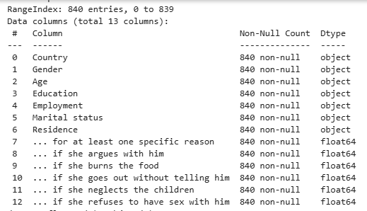

Decision trees:
For the decision tree analysis all demographic predictors were one-hot encoded within a ColumnTransformer to ensure consistent transformation of training and test sets. Because the target variable had imbalanced classes, the SMOTE(Synthetic Minor Oversampling Technique) algorithm was applied.
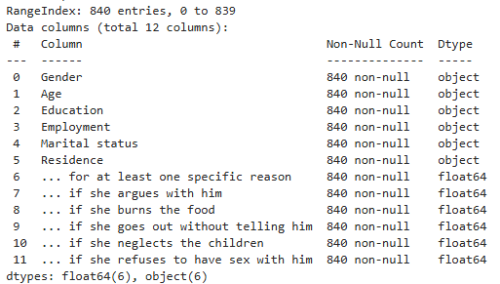

In all methods, the preprocessing involved date handling, reshaping demographics, merging question responses, encoding categorical variables, handling missing data and removing non-numeric identifiers. Next, the preprocessing was model-specific: for PCA and logistic regression we focused on encoding and standardization, while for decision trees we focused on categorical handling and class balance.

Data analysis

Principal Component Analysis

Principal Component Analysis was applied to the preprocessed dataset to explore the underlying structure and identify the demographic features most strongly associated with attitudes toward intimate partner violence. PCA was performed without specifying the number of components, allowing extraction and inspection of the full variance structure. Multiple strategies were explored, such as using one-hot and label encoding and performing PCA on all features or separately for each survey question.

- PCA on all features using label encoding

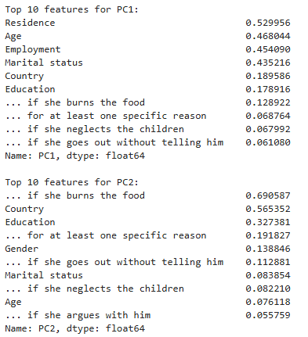
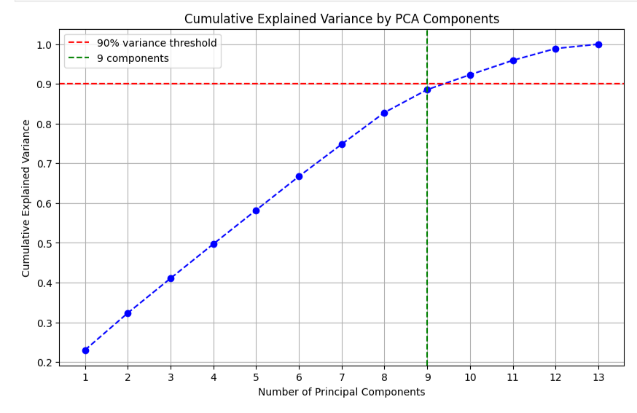
Applying PCA to the label-encoded dataset showed that the first few components captured a big proportion of the total variance. The cumulative variance plot indicates that 9 components were enough to account for approximately 90% of the variation. This suggests that the data is redundant and can be reduced without significant loss of information.
Figure 4
Figure 5 PCA loadings

The PCA loadings (Figure 5) revealed which original features contributed the most to each principal component. The first PC was influenced by demographic characteristics such as residence, age, employment and marital status. The second PC captured variation related to specific survey responses. Together these components highlight 2 dominant axes in the data: the demographic dimension and a survey-response dimension.

- PCA on all features using one-hot encoding

Using one-hot encoding resulted in 21 principal components, matching the number of input features. The PCA loadings showed that PC1 was again influenced by the demographic attributes: residence, age, employment and marital status. The largest loadings were observed for: rural(0.38), 15-24 year olds(0.34), employed for cash(0.34) and married(0.33). PC2 was dominated by gender, education, marital status and employment. PC2 was shaped primarily by gender and education, with employment and marital status contributing slightly. The heatmap of the first 10 components (Figure 6) reveals highly correlated demographic features.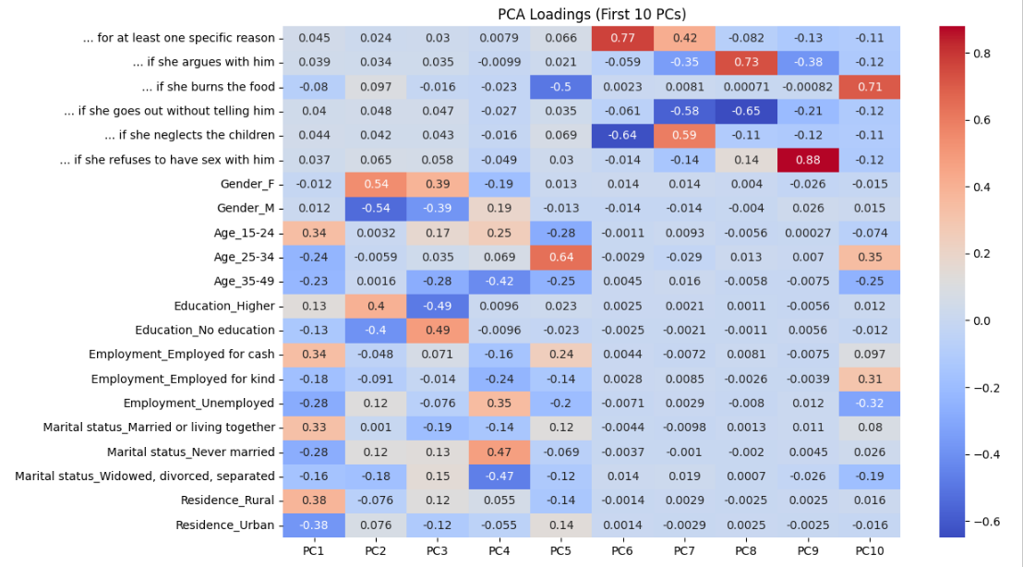
Figure 6
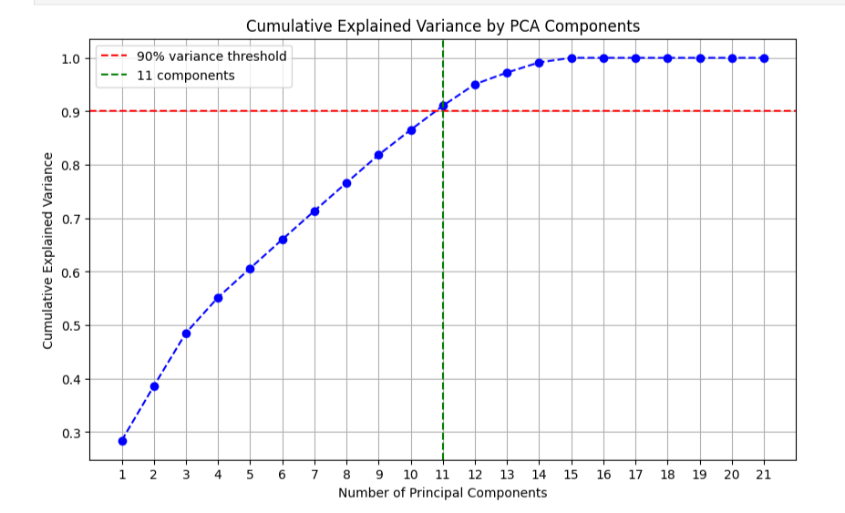
Figure 7
The cumulative explained variance curve (Figure 7) shows that the first 11 PCs together account for 90% of the total variance, most of the variation being captured by PC1 and PC2.

- PCA performed separately for each survey question

To better understand factors associated with intimate partner violence justification, we conducted PCA separately for each survey item using the one-hot encoded dataset. For each question, a loadings heatmap and a cumulative explained variance curve were generated.

Across all IPV justification scenarios, the structure of the first principal component was constant. The same demographic factors consistently dominated PC1: residence (rural or urban), age 15-24 group, employment for cash and being married or living together. This consistency indicates that the primary demographic axis underlying IPV attitudes does not depend on the specific scenario.

Notably, justification responses did not load strongly across items, suggesting that endorsement of one reason for IPV does not predict endorsement of another.

The cumulative explained variance plots indicate across all questions that 10 components are needed to capture 90% of the variance. This suggests that attitudes toward IPV justification reflect multiple overlapping socio-demographic influences.

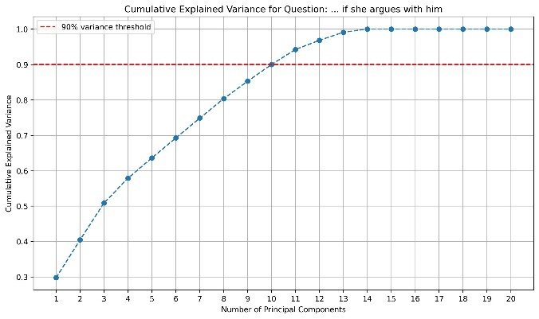
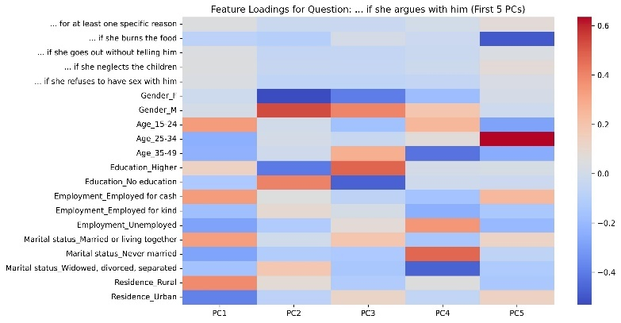
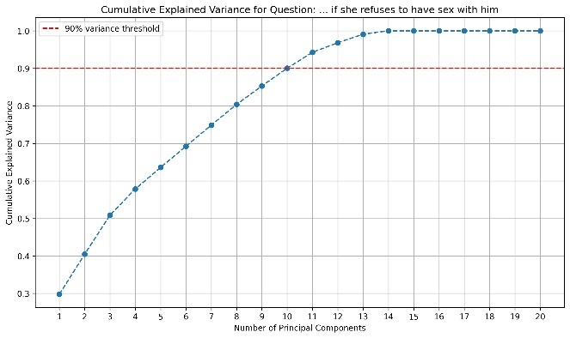
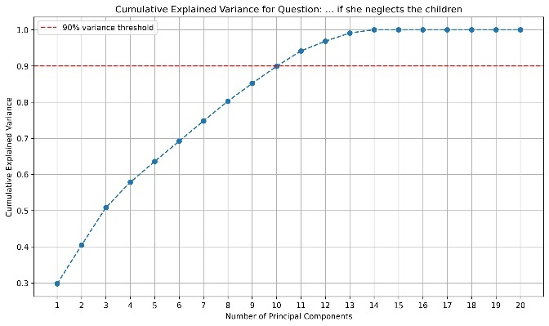
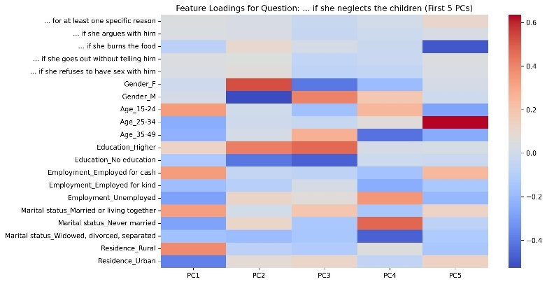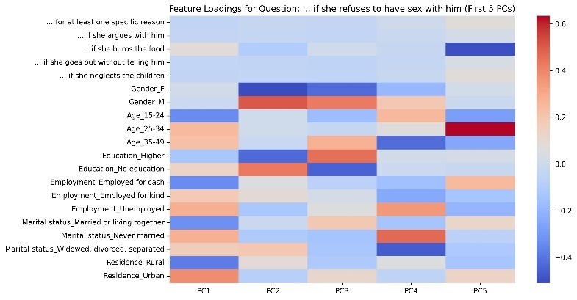
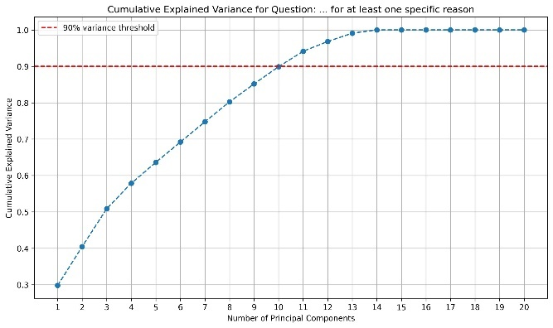
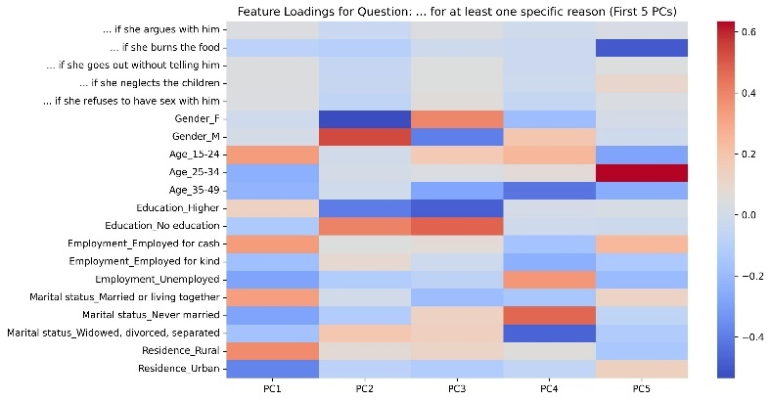
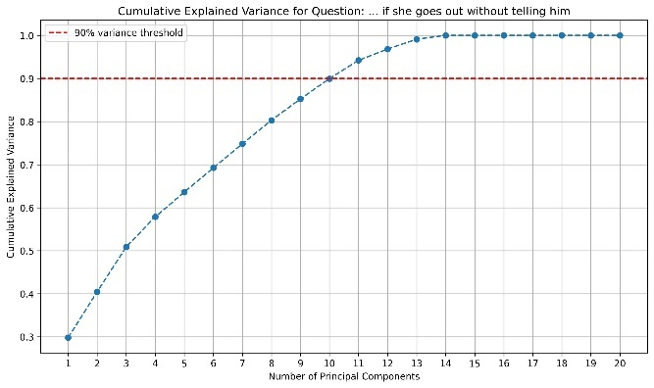
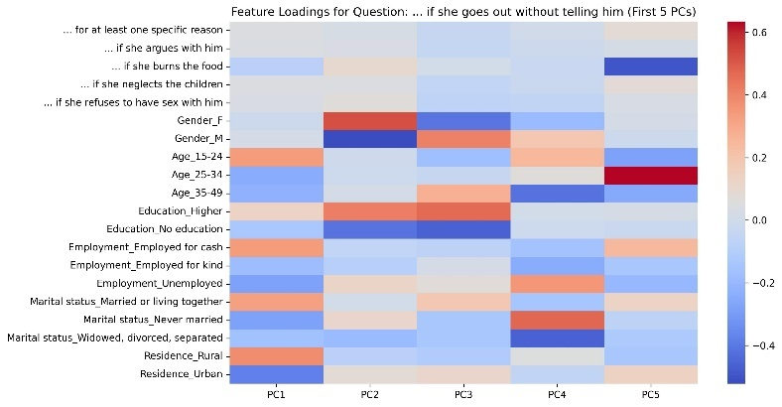

- PCA per question while excluding all other survey questions

To isolate demographic structure even more cleanly, PCA was repeated for each IPV justification item after removing all other survey questions from the feature space. This ensured that variance patterns were influenced just by demographics, not by correlations among survey items. Across all 6 IPV justification items, PC1 accounted for the largest share of variance and the loading structure was nearly identical. The Residence_Rural and Residence_Urban attributes had symmetric and opposite loadings, indicating that the rural-urban divide is the dominant dimension shaping demographic structure. The age group 15-24, employment for cash, and being married or living together were consistently the highest contributors.

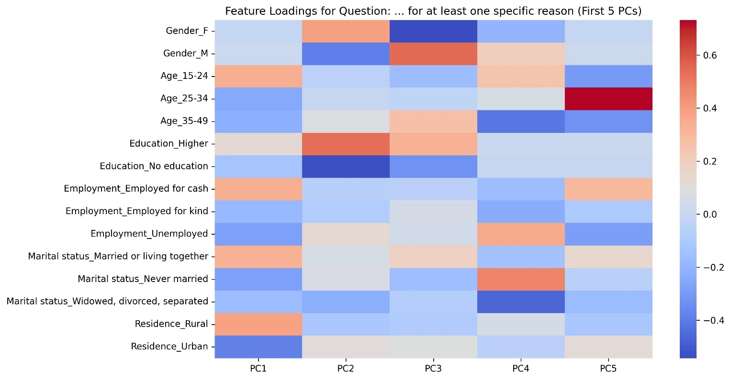

Summary
This analysis confirms that the demographic variation relevant to IPV attitudes is highly stable across items. The strongest predictions are structural rather than item-specific, supporting the interpretation that demographic context (rural residence, youth, economic activity and marital status) plays a central role in shaping IPV attitudes. (Paragraph written with the help of generative Ai)

Logistic regression

Logistic regression is used for modeling binary outcomes based on one or more predictor variables. In survey-based research, it allows for the assessment of relationships between demographic factors and responses, even with predictors including a mix of categorical and continuous variables. For each IPV justification item, a separate logistic regression model was trained to predict a binary outcome. The dataset was split into training and testing using a 75/25 split. Models were initialized with class_weight=’balanced’ to account for imbalance in the binary target, and the maximum number of iterations was 500 to ensure convergence. To interpret the model, feature names (original numerical features and the one-hot encoded categorical features) and corresponding coefficients from the logistic regression were paired to interpret the relative importance and direction of each predictor. This was repeated for all questions for multiple strategies for binary target creation.

- Binary target based on mean

Thresholds based on the mean of the response “yes” percentage for each question were used to define binary outcomes. This preserved the natural distribution of responses, reflecting the survey population. Because many questions had heavily skewed values, the resulting class balance was uneven, limiting predictive performance.
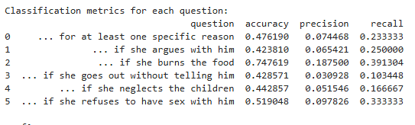
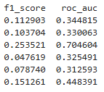

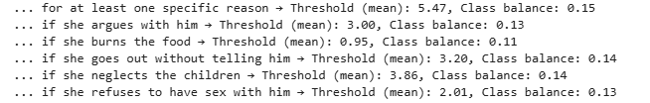

The performance metrics indicate that the model struggled for most questions with low prevalence of positive responses, resulting in poor precision and F1-scores, despite moderate accuracy. The exception question “…if she burns the food”, suggests that the predictors were better for this outcome.

Examination of the top features for each question showed that the Country variable consistently had a negative impact on the likelihood of a positive IPV response.

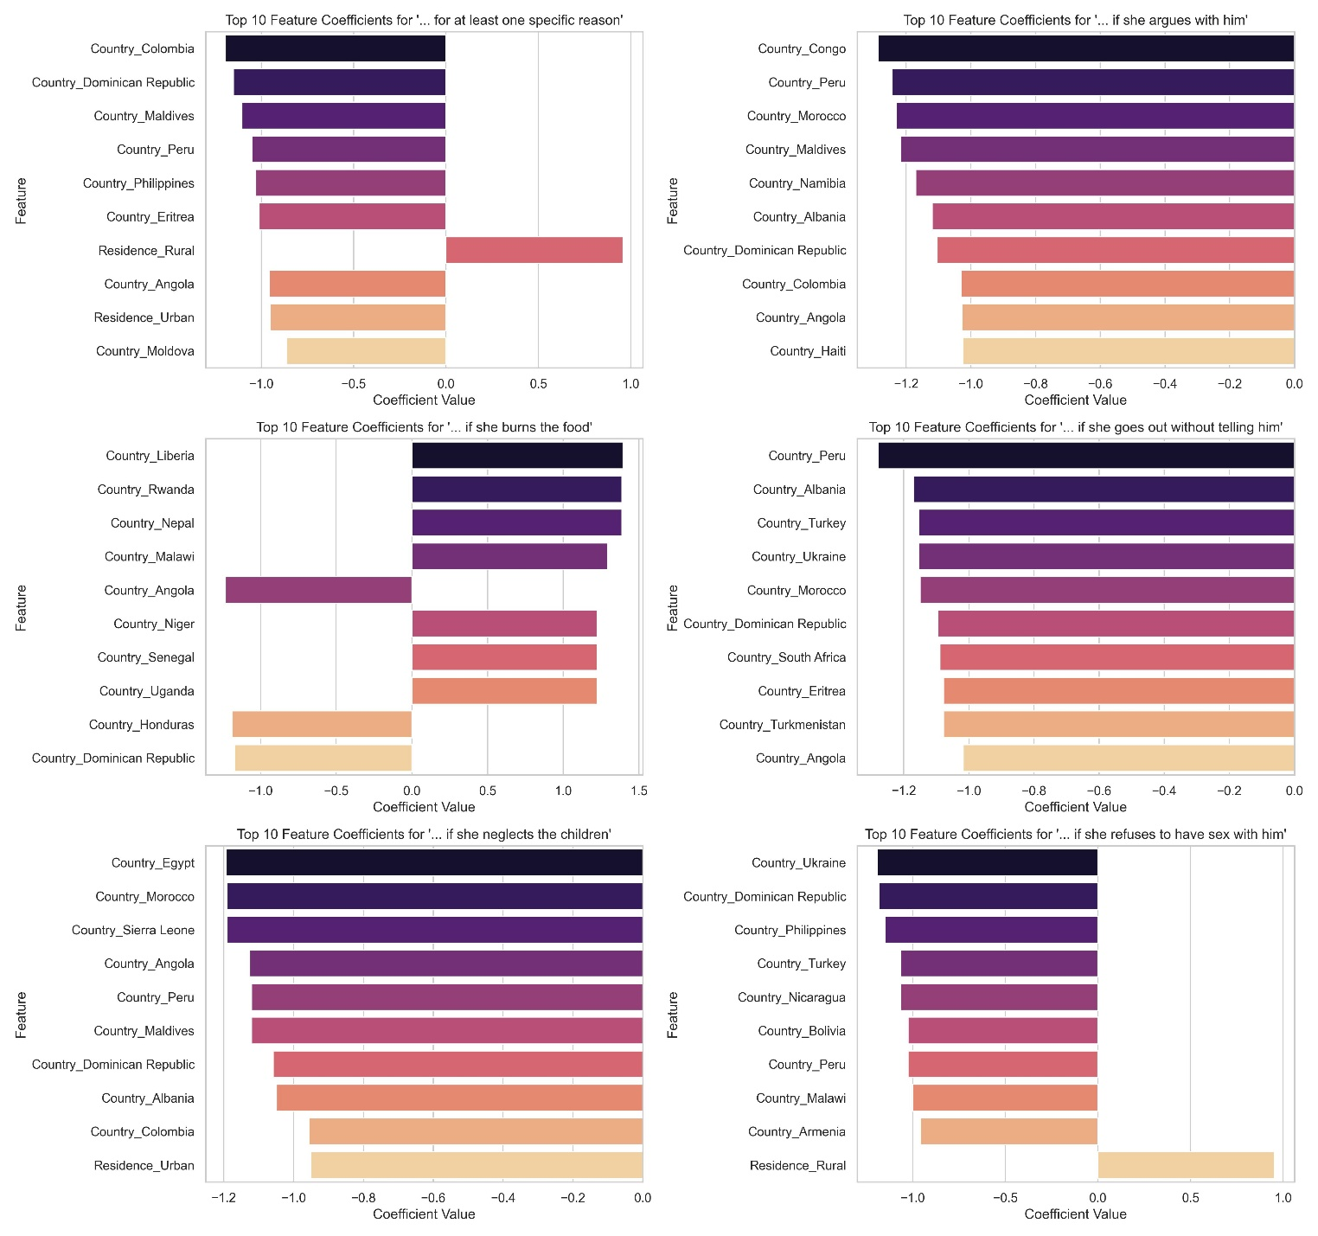

- Binary target based on mean, excluding country
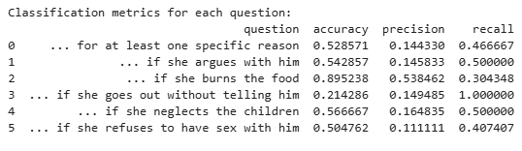
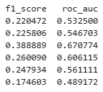

By excluding the Country feature, all performance measures improved. Analysis of feature coefficients revealed that the strongest predictors for a positive IPV response were rural residence, employment status, marital status and the 15-24 age group. This suggests that the country-level effects were overshadowing other important demographic predictors.
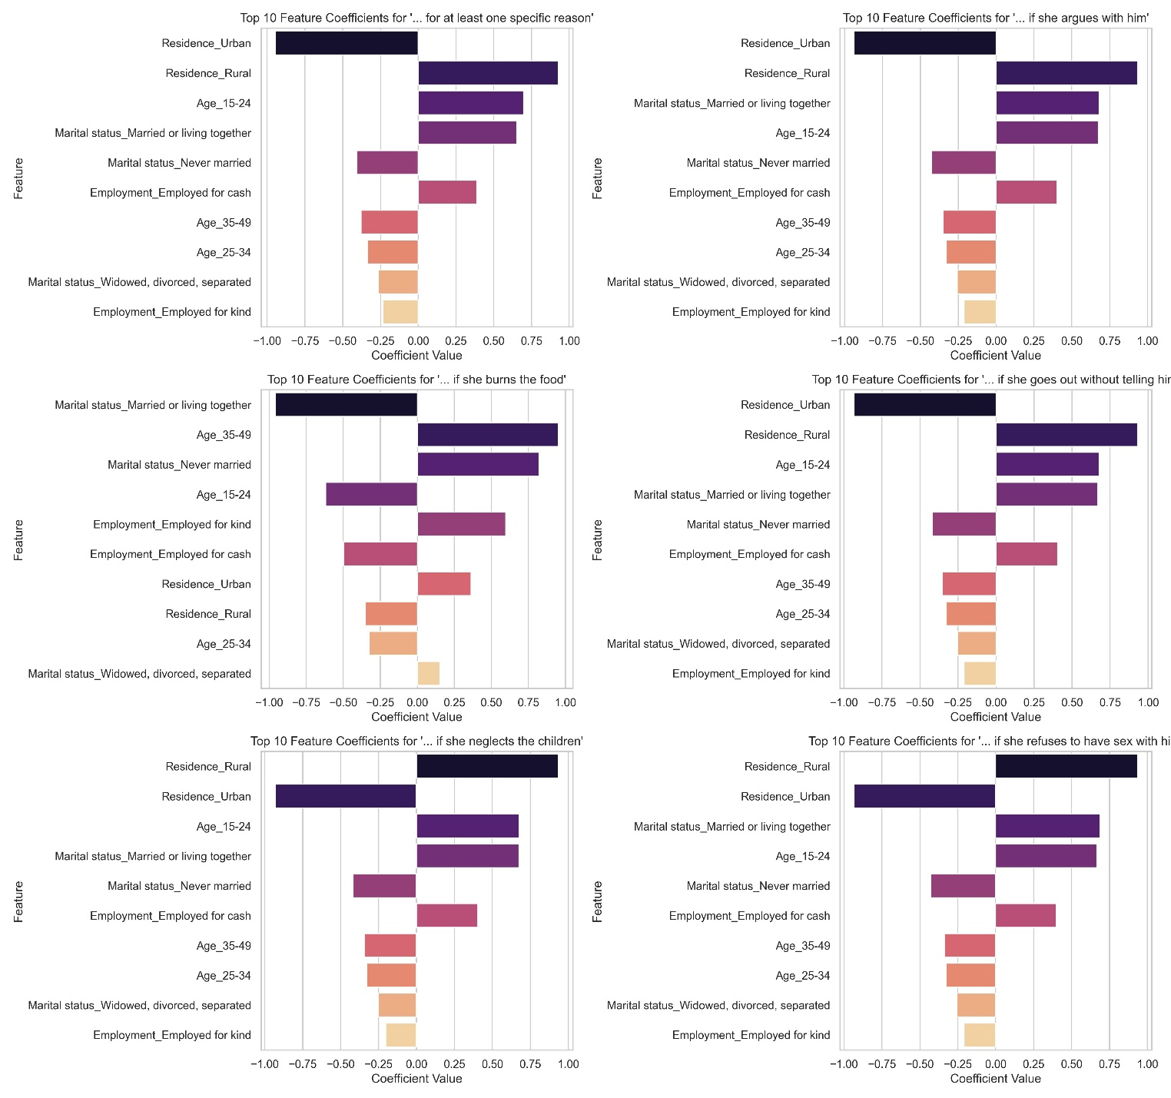

- Binary target with Min/Max ratio

This method enforced a minimum and maximum proportion for the minority class, ensuring that rare responses were not completely ignored. Thresholds were set using percentile-based adjustments. The predictive performance matched that of the evenly balanced method, indicating that controlling extreme class imbalances helped preserve signal without introducing substantial bias.

- Evenly balanced binary target

This approach aimed to balance classes at approximately 50/50 by adaptively determining thresholds based on sorted response values. This strategy improved the representation of minority responses, but it introduced artificial splits that did not reflect the natural distribution, affecting reliability. This approach slightly increased predictive accuracy for some questions, but the overall model performance was limited for questions with low response rates.
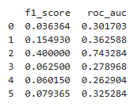
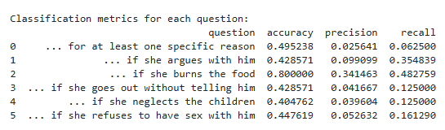

- Evenly balanced binary target, excluding country

Excluding the Country feature in the evenly balanced models produced mixed efects. For 3 out of 6 questions accuracy dropped, while the others showed improvements. The precision, recall and roc score grew for all questions.

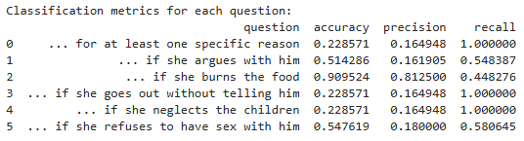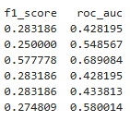

The IPV justifications predictors reaimed consistent with previous models, except for the “if she burns the food” question, which was mostly influenced by urban, unemplyed, divorced 35-49 year olds.

Summary
Mean-based targets preserved the natural response distribution but caused class imbalance, limiting model sensitivity. Evenly balanced and Min/Max methods improved minority class representation but introduced artificial threshold, affecting interpretability. Excluding the Country often highlighted key demographic predictors, such as rural residence, employment, marital status and age, while shift occurred for certain questions.

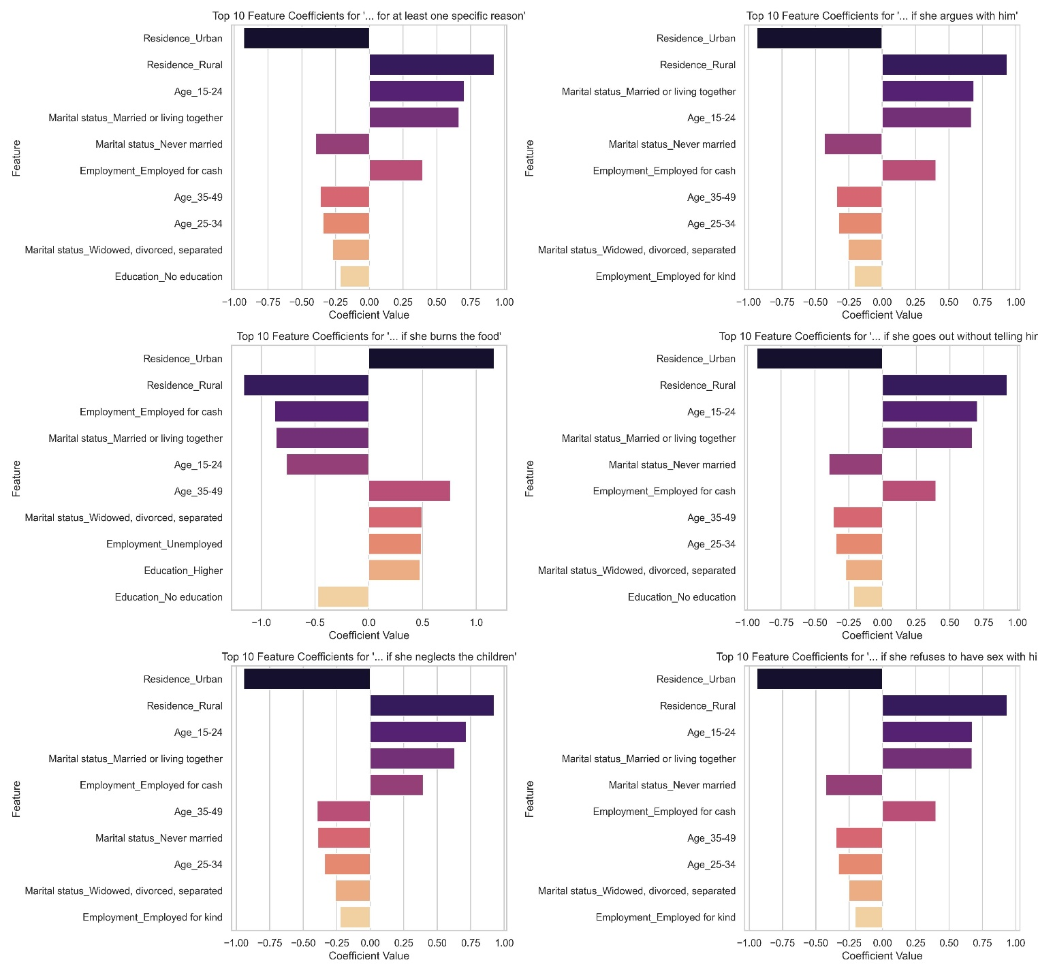

Decision Trees

To predict responses to survey questions on the justification of violence against women and girls, we used decision tree classifiers. Predictor variables included demographic features (gender, age, education, employment, marital status and residence) and the target variables were obtained from survey responses and converted into binary or 3 class outcomes. We evaluated 2 preprocessing approaches: oversampling with SMOTE/SMOTENC and using class-weighted decision trees without oversampling. The dataset was split into training and test sets(75/25) and stratified by the target class. Model performnece was measured on accuracy, confusion matrices, precision, recall and F1-score.

Without SMOTE

In the first approach standard decision trees were trained on demographic features and balanced class weights. Different tree depths(3,5,7,10,15) were tested, but the performance stayed constant, with an overall accuracy of 0.2047 for all depths. The confusion matrix was [[ 14 167] [ 0 29]] revealed severe class imbalance. Feature importance showed that rural residence dominated predictions, with a 0.9145 importance, followed by marital status with a 0.06 importance. The model relied heavily on rural residence to predict outcomes, showing that demographics were biased and that oversampling is needed.

Decision tree with SMOTE

Oversampling with SMOTE was used to handle the class imbalance in the target variable. Despite balancing the classes, accuracy remained 0.2047 for all tested tree depths.

3 class target and SMOTENC

Survey responses were converted into 3 levels: 0(no justification), 1(minor justification) and 2(high). SMOTENC was applied to oversample the minority classes, accounting for categorical demographic features. Gender_F was the most important feature, with 89% importance, followed by residence. Introducing multiple classes leads to lower accuracy (0.148).

SMOTENC decision tree with demographics and other survey questions

Models were trained using both demographic features and survey responses. SMOTENC was applied before one-hot encoding, balancing categorical and numerical features. One-hot encoding was applied only to demographic features. The decision tree classifiers were trained with varied class weights and min samples per leaf in order to evaluate model performance across different complexities. The heatmap visualizes how accuracy varies across combinations of max_depth and min_samples_leaf. Accuracy improved with increasing tree depth, stabilizing after depth 7. This shows that deeper trees captured more complex patterns in the data. Class-specific performance showed:
- Class 0(no incidents) precision remained high, indicating few false positives
- Class 1(low prevalence) precision and F1-scores were lower because of difficulty in distinguishing low-prevalence cases
- Class 2(high prevalence) precision and F1-score improved with deeper trees.
Min Samples Leaf had a minor effect on accuracy but influenced F1-scores. Smaller leaf sizes allow the model to capture smaller patterns.
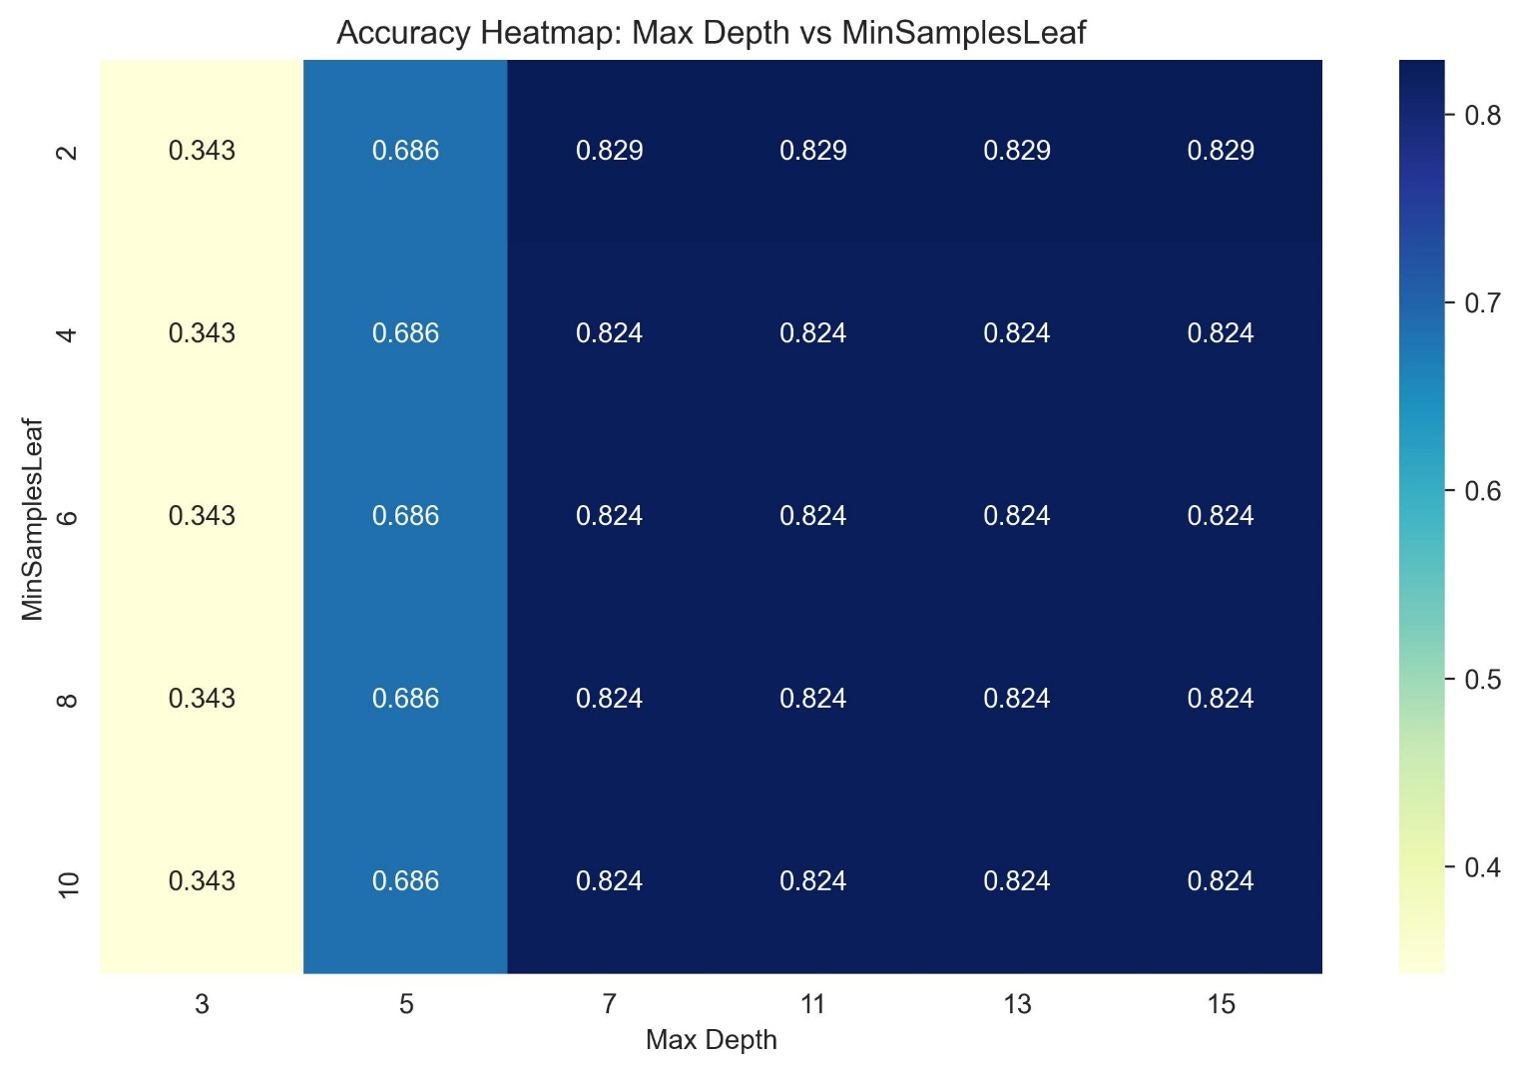
The best approach was the decision trees with SMOTENC, with the optimal hyperparameters max depth = 7 and min samples leaf =2.

Feature importance analysis consistently identified Gender (Male) as the most influential predictor across all questions, accounting for approximately 32-36% of importance. This indicates that male respondents are more likely to endorse various forms of violence. Other influential factors were the survey items. This suggests a strong interdependence in attitudes toward different types of violence. Demographic factors beyond gender, such as age group and residence type were generally less important but did contribute to model predictions. Overall, these findings indicate that male respondents and the endorsement of specific behaviors jointly drive the patterns observed in survey responses, reflecting demographic influences and attitudinal correlations.

Summary
Decision trees with SMOTENC oversampling provided the best predictive performance. Male gender and prior survey responses were the strongest predictors, reflecting demographic influence and correlated attitudes toward IPV. Deeper trees captured more complex patterns, especially for high-prevalence responses.

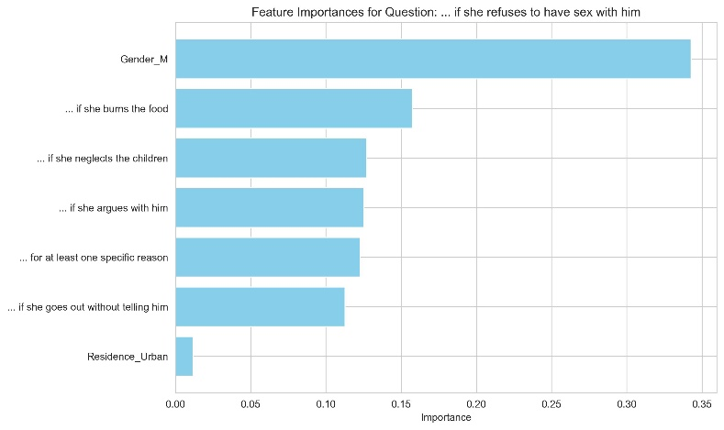
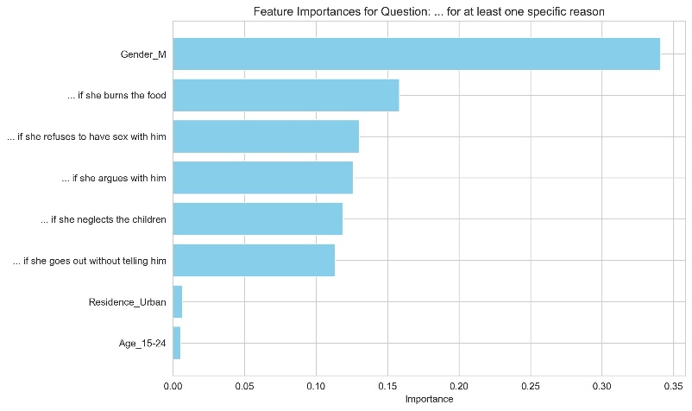
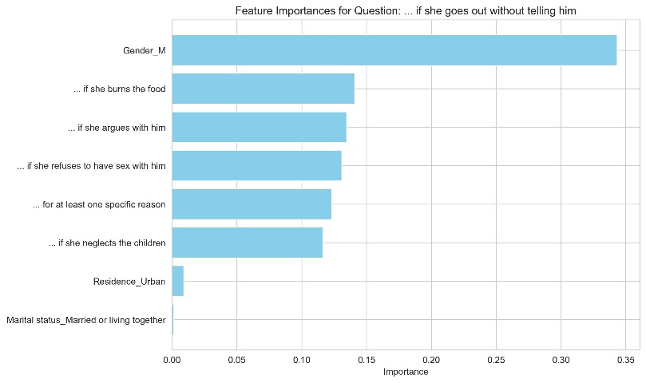
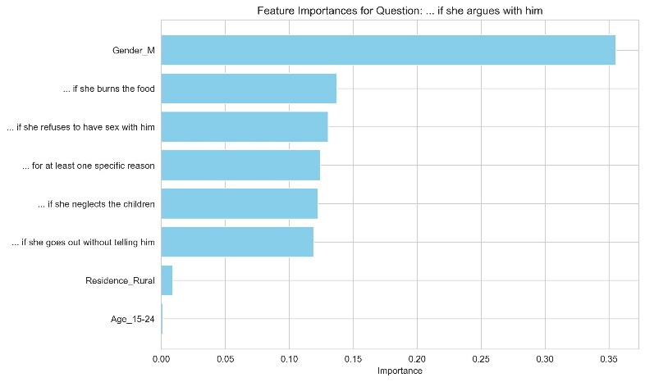
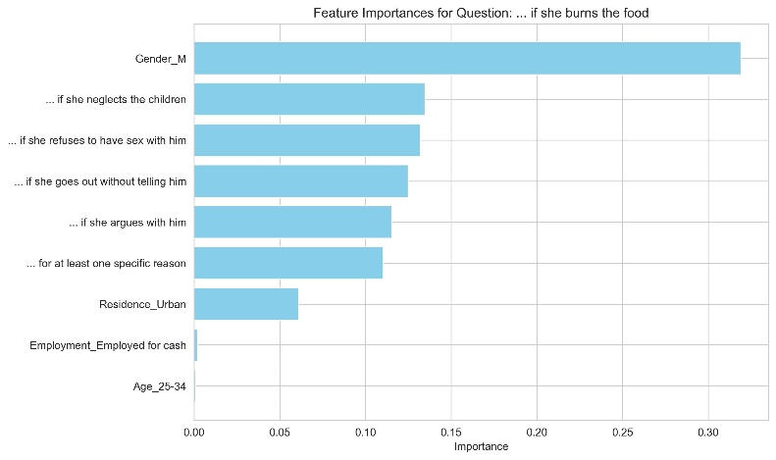
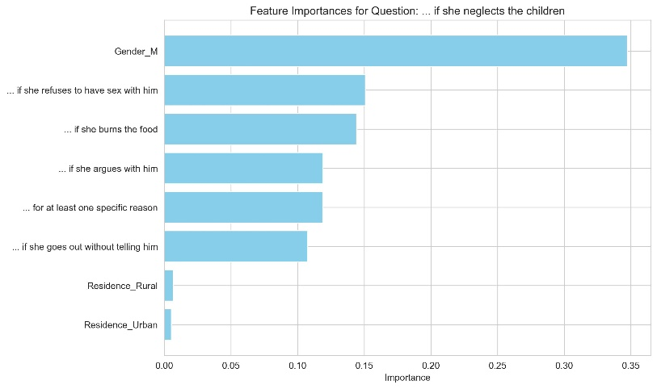

Conclusion

The analysis demonstrates that demographic context plays a dominant role in attitudes toward IPV, with rural residence, youth, marital status, and employment status being consistent predictors across multiple approaches. PCA revealed stable, underlying demographic structures that account for most of the variance in IPV justification, independent of other survey questions. Logistic regression further showed the importance of these demographic features when the country identifiers were excluded, although class imbalance limited performance for low-prevalence responses. Decision trees combined with SMOTENC oversampling captured interdependencies between demographic features and prior survey responses, identifying the male gender and endorsement of other IPV behaviors as the strongest predictors. The findings strengthen the need for context-sensitive interventions that consider both structural demographic factors and attitudinal correlations.

Bibliography

Abdi H, W. L. (2010). Principal component analysis. Wiley interdisciplinary reviews: computational statistics 2(4), 433-459.
Anasel, M. G. (2024, Nov 25). A Logit Regression Approach to Identifying Predictors of Intimate Partner Violence in Tanzania. East African Journal of Applied Health Monitoring and Evaluation 7, no. 2.
Best, H. a. (2015). Logistic regression. In The SAGE handbook of regression analysis and causal inference (pp. 153-171). Los Angeles: Sage.
Coll CV, S. T. (2021). Identifying the women most vulnerable to intimate partner violence: A decision tree analysis from 48 low and middle-income countries. EClinicalMedicine 42.
Greenacre, M. G. (2022). Principal component analysis. Nature Reviews Methods Primers 2(1), 100.
Hacıaliefendioğlu A, Y. S. (2020). Co-occurrence patterns of intimate partner violence. In BIOCOMPUTING 2021: Proceedings of the Pacific Symposium, 79-90.
LaValley, M. P. (2008). Logistic regression. Circulation 117, no. 18, 2395-2399.
Song, Y.-Y. a. (2015). Decision tree methods: applications for classification and prediction. Shanghai archives of psychiatry.

